APPLICATION FOR MEMBERSHIP
SUBJECT TO MANAGEMENT COMMITTEE APROVAL
CABOOLTURE ORCHID SOCIETY INC.
Membership Required: - Single or Family $20.00 per annum (Pro Rata Applies)
Name: - Mr. Mrs. Miss Ms…………………………………………………………………………………………..………..
Preferred given Names …………………………………………………………………………………………….…………….
Caboolture Orchid Society Inc
The Caboolture Orchid Society Inc was formed in 1969 and has over 100 members.
Anyone interested in joining is welcome to at3 meetings as a guest.
The society holds 3 meetings per month:
The day cultural meeting is held at the Combined Services Hall Hayes St Caboolture on the 3rd Friday of the month starting at 1.00pm. We park and meet at the rear of the hall.
The management committee meeting is held on the Monday following the day meeting starting at 1.00pm at a selected venue.
We also have regular grower’s meetings on Saturday mornings at different venues.
Your Membership is valid after approval by the Management Committee and payment has been made. A membership kit to assist your orchid journey with us will be presented to you at your first meeting following this.
Membership allows members access to monthly bulletin and participation in all the society’s activities e.g. bus trips and shows etc. and purchase of Orchid growing supplies.
Each member of the Caboolture Orchid Society is automatically an associate member of the Sub Tropical Council of Queensland Inc STOCQ
The society tries to impart as much information as possible about orchids, generally and culturally. We have guest speakers and or photo presentations at meetings. Members are willing to answer questions and assist new members.

Address …………………………………………………………………………………………………………………..………………
Email Address …………………………………………………………………………………………………………..…………….
Signature ……………………………………………………. Contact Telephone No …………………………………….
Proposed By …………………………………… (A Financial Member) Seconded By……………………………………(A Financial Member)
Approved by Management Committee……………………………………………. Date ……………………………….
Emergency Contact Name: _______________________ Phone Number _____________________

CABOOLTURE ORCHID
SOCIETY INC.

Membership Application

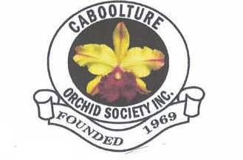
Postal Address
PO Box 549 Caboolture Qld 4510

